A PROJECT REPORT

# “GSM BASED WATER PUMP CONTROL SYSTEM” UNDER THE GUIDANCE OF

PROF.NAZISH FATIMA

# SUBMITTED BY

**Ayman Attar**

**Sumedh Pathrudkar**

**Bhagyashri Kalkure**

**IN COMPLETE FULLFILLMENT OF THE REQURIREMENTS FOR THE DEGREE OF**

**BACHELOR OF ENGINEERING**



**DEPARTMENT OF**

**ELECTRONICS AND TELECOMMUNICATION ENGINEERING SHALAKA FOUNDATION**

**KEYSTONE SCHOOL OF ENGINEERING (2021-2022)**



**SHALAKA FOUNDATION’S KEYSTONE SCHOOL OF ENGINEERING**

**CERTIFICATE**

**THIS IS TO CERTIFY THAT PROJECT ENTITIES**

**“GSM BASED WATER PUMP CONTROL SYSTEM”**

# SUBMITTED BY

**Ayman Attar**

**Sumedh Pathrudkar**

**Bhagyashri Kalkure**

Is a record of the bonafide work carried out under the supervision of Prof. Nazish Fatima and is approved as the partial fulfilment of the requirement of the award of degree in Electronic and Telecommunication

Engineering of the University of Pune.

**Prof. Sheetal Whagchaware**

**Project Co-Ordinator**

**Depatrment Of E&tc**

**Prof. R.A. Barapte**

**Head Of The Department**

**Depatrment Of E&tc**

**Principal**

**Prof. Nazish Fatkima**

**Guide**

**Depatrment Of E&tc**

**Place : Pune**

**Date :**

# ABSTRACT

* In present days, we prefer automation in every sector and are bendy to use. It offers large precision and consistency with high term operation as fair as the manual operated systems.
* Our project is the automation of the Electric Water Pump used in households, industries, agriculture etc. Our effort is to make and achieve the mechanization implementation to manage electrical motor with the help of GSM module in agriculture use case.
* With this the user can monitor the Water Pump by just sending commands through the SMS. The main contribution of this work is to offer automatic water supply for plants to saving time as well as water.
* This will ease the work of farmers as they can monitor the Water Pump by just sending commands through SMS which will reduce their physical work.
* The proposed system is controlled by Arduino to turn ON/OFF of pump by checking the moister level with the help of moisture sensors. the GSM technology is also used to switch ON/OFF of the pump using mobile phone by sending the commands to the kit through the GSM modem.

# ACKNOWLEDGMENT

Every orientation work has an imprint of many people and it becomes duty of author to express deep gratitude for the same.

We would like to take this opportunity to express true sense of gratitude towards our project

guide **Prof. Nazish Fatima** for her valuable co-operation and guidance that gave us for this project.

We would also like to thank our head of the department **Prof. R. A. Barapate** for inspiring us and providing us all lab facilities with internet, which helped us with the project work.

We would also like to express our appreciation and thanks to all those who knowingly or unknowingly have assisted us & encouraged us for our project.

# INDEX

|  |  |  |
| --- | --- | --- |
| Sr.No | content | Page No |
| 1 | Introduction | 6 |
| 2 | Literature Survey | 8 |
| 3 | Problem statement & objective | 10 |
| 4 | Specifications | 12 |
| 5 | Block diagram and Description | 14 |
| 5.1 | Block Diagram | 15 |
| 5.2 | Block diagram Description | 16 |
| 5.3 | Circuit Diagram | 18 |
| 6 | Software Implementation | 19 |
| 6.1 | Flow Chart | 20 |
| 7 | Advantages and Application | 21 |
| 7.1 | Advantages | 22 |
| 7.2 | Applications | 22 |
| 8 | Conclusion | 23 |
| 9 | Future Scope | 25 |
| 10 | Reference | 27 |
| 11 |  | 29 |

**CHAPTER NO.1**

**INTRODUCTION**

# INTRODUCTION

* **Agriculture based economy could lead a country towards an economically independent nation. Undoubtedly, India is an agricultural country, and its economy depends on farming.**
* **One of the essential elements for successful farming is that we should lighten the burden on the farmers so that their productivity level can be increased. We can reduce the burden on farmers by automating the water supply system. That’s not a lot but can be helpful.**
* **Our proposed system automates the monitoring of the water supply and water requirements of the plants with the help of specific sensors.**
* **In the traditional water supply system the farmer would have to monitor the water supply by himself and would have to turn on and off the water pump accordingly. But in this system the controller will do the work for farmer.**
* **Besides the system also gives the farmer full control of the water pump. He can turn on and off the pump whenever it is necessary by just sending a text message through his mobile phone. This will not only lighten the burden of the farmer but also will help him reduce the wastage of water and much more.**

# CHAPTER NO.2 LITERATURE SURVEY

**2.LITERATURE SURVEY**

|  |  |  |  |  |
| --- | --- | --- | --- | --- |
| **Sr.**  **No.** | **Papers** | **Year of**  **Publish** | **Author** | **Method Used** |
| **1.** | **Smart Monitoring of Agricultural Field And Controlling of Water Pump Using Internet of Things** | **2019** | **Mr.M.Suresh, S.Ashok, S.Arun Kumar, Puppala Sairam** | **IOT** |
| **2.** | **Solar Based Automatic Irrigation System with GSM Module** | **2019** | **Md. Munirul Islam Tusher, Md. Zahirul Haque, Mohammad Jalal Uddinǂ , Arif Mainuddin , Mohammad Ehsanul Hoque, Md. Mohin Uddin Talukder** | **Embedded System** |
| **3.** | **Automatic Water Supply System for Plants by using Wireless Sensor Network** | **2017** | **Santhosh Hebbar, Golla Vara Prasad** | **Embedded System** |
| **4.** | **Designing a central control unit and soil moisture sensor based irrigation water pump system** | **2013** | **Pulkit Hanswal, Ojaswi Dale, Deepika Gupta, R. N. Yadav MANIT** | **Embedded System** |

# CHAPTER NO.3

**PROBLEM STATEMENT**

**& OBJECTIVE**

# PROBLEM STATEMENT

To implement GSM based water pump control system by Using Arduino At mega 2560 and programming language embedded c

# OBJECTIVE

The purpose of this project is to save wastage of water, which is done by detecting soil moisture using soil moisture sensor

The gsm based water pump control system transfers SMS to the receiver mobile by track the status of moisture level.

# CHAPTER NO. 4

**SPECIFICATIONS**

# 4.SPECIFICATIONS

## Hardware

* Power supply adapters
* Arduino Uno
* Gsm SIM800A module
* Soil moisture sensor(FC-28)
* Water flow sensor (YF – S201)
* WATER PUMP
* Relay module

## Software Specification

* Proteus 8
* Arduino Software (IDE)

# CHAPTER NO.5

**BLOCK DIAGRAM**

**& DESCRIPTION**

**5.1 BLOCK DIAGRAM**

ARDUINO UNO

GSM MODULE

SOIL MISTURE SENSOR

WATER PUMP

GSM MODULE

POWER SUPPLY

# 4.DESCRIPTION

## Arduino UNO :

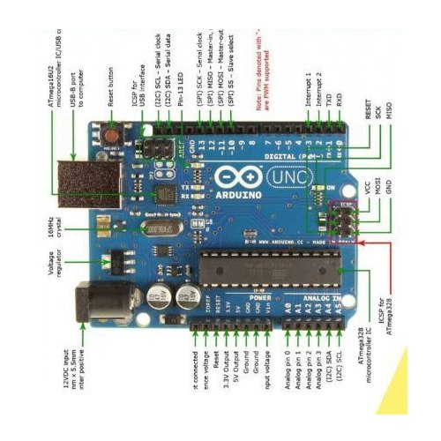

|  |  |
| --- | --- |
| **Microcontroller** | **ATmega328P-8 bit AVR family microcontroller** |
| Operating voltage | 5V |
| Recommended input voltage | 7-12V |
| Analog input pins | A0-A5 |
| Digital I/O pins | 6(13,12,8,7,4,2) |
| PWM digital I/O pins | 6(11,10,9,6,5,3) |
| Serial pin | 0(Rx)  1(Tx) |
| SPI | 10(SS)  11,12(MOSI)  13(SCK) |
| DC current on I/O pins | 40mA |
| DC current on 3.3V pin | 50mA |
| Flash memory | 32Kb (0.5 used for bootloader ) |
| SRAM | 2Kb |
| EEPROM | 1Kb |
| Frequency | 16MHz |

1. **GSM SIM 800A module :**

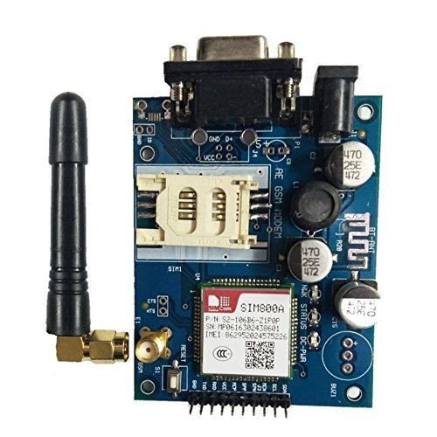

|  |  |
| --- | --- |
| Name | SIM800A quad band GSM module |
| Bands | 850/900/1800/1900MHz |
| Pins | TXD,RXD,VCC,MCP,SPP,SPH,MCN,SCL,SDA |
| Voltage supply | 9vDC-12vDC |
| Supply current | 2A |
| Cooding schemes | CS-1, CS-2, CS-3, CS-4 |
| Class | 4 (2W), Class 1 (1W) |
| Control via AT commands | (3GPP TS 27.007, 27.005 and SIMCOM enhanced AT command set) |

1. **Soil Moisture Sensor specification (FC-28)**

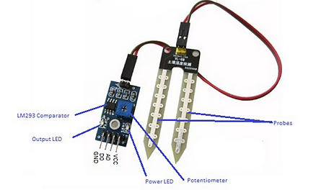

|  |  |
| --- | --- |
| **Name** | **Soil moisture sensor** |
| Operating Voltage | : 3.3V to 5V DC |
| Operating Current: | 15mA |
| Output Digital | 0V to 5V, Adjustable trigger level from preset |
| Output Analog | 0V to 5V based on infrared radiation from fire flame falling on the sensor |
| Pins | VCC(The Vcc pin powers the module, typically with +5V) |
|  | GND(Power Supply Ground) |
|  | DO(Digital Out Pin for Digital Output) |
|  | AO(Analog Out Pin for Analog Output) |

1. **Water pump specification**

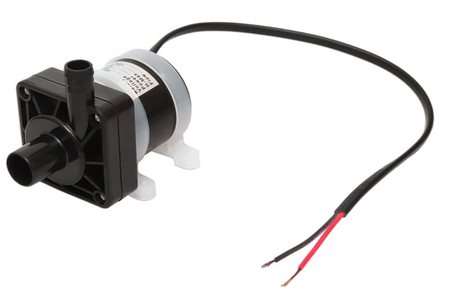

|  |  |
| --- | --- |
| **Voltage** | **DC 12V** |
| Power | 8W |
| H-max | 5m |
| Flow | 10L/min |

**5.3 CIRCUIT DIAGRAM**

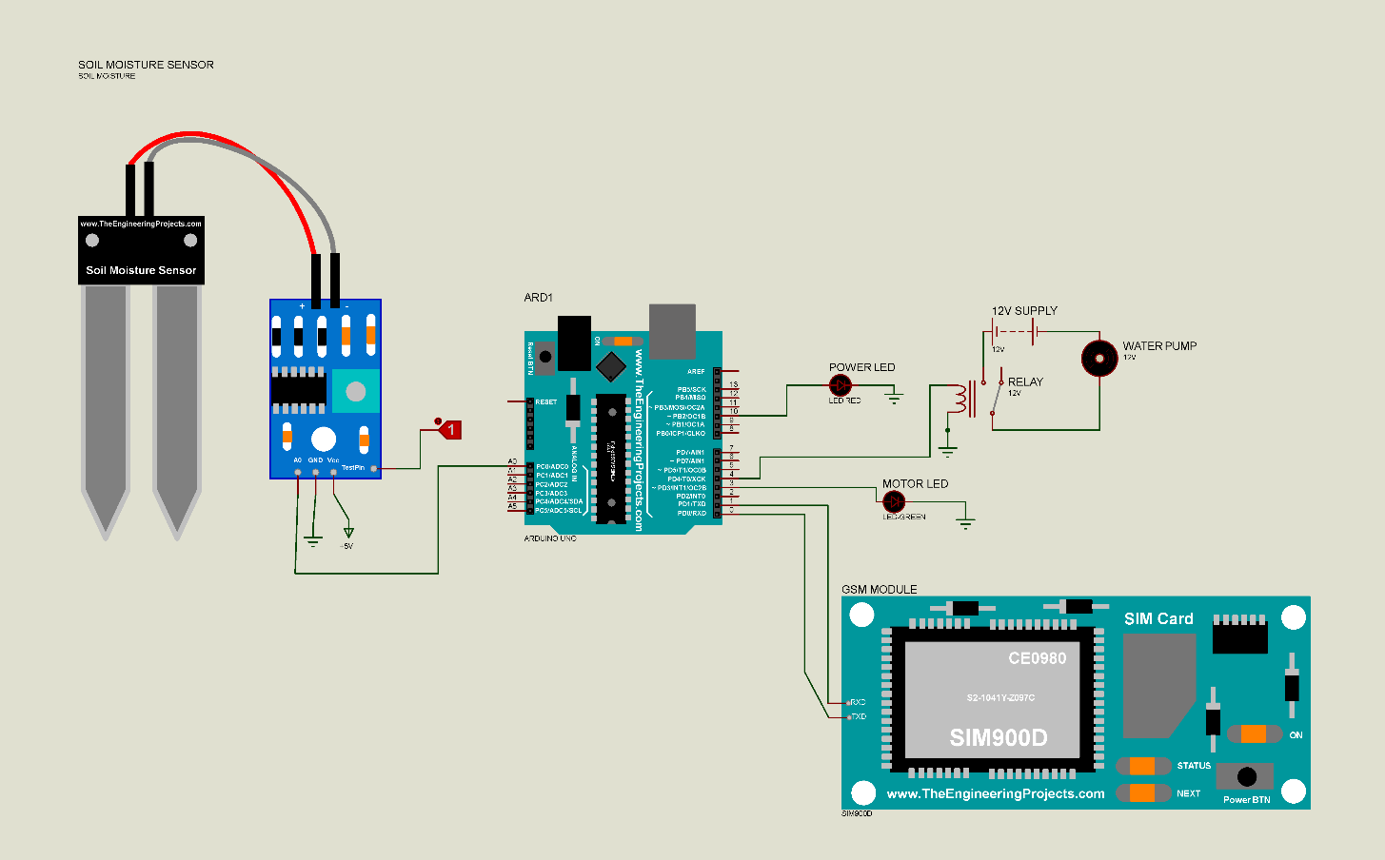

# CHAPTER NO.6

**SOFTWARE IMPLEMENTATION**

# 6.1. FLOW CHART

**START**

**Immediate GSM initialization**

**Soil moisture sensor will keep reading the moisture in the soil**

**MOISTURE <= 30%**

**Motor will ON**

**State = 1**

**MOISTURE >= 30%**

**Motor will OFF**

**State = 0**

**End**

**GSM will send the message to recorded phone number in code**

**GSM will send the message to recorded phone number in code**

**CHAPTER NO.7**

**ADVANTAGES & APPLICATIONS**

* 1. **ADVANTAGES**
* Use of this system will save farmers time and money.
* Reduces the burden of farmers also increases their productivity.
* It can be easily implemented in the fields.
* It is user friendly**.**
  1. **APPLICATIONS**
* This system can be used in the agricultural watering pumps.
* It also has wide applications in the industrial as well as household water pumps

# CHAPTER NO. 8

**CONCLUSION**

**8. CONCLUSION**

1. If the power supply of the system goes OFF, we cannot get the status of the system so a backup power supply system can be provided for the microcontroller and the GSM unit. It will give the system information even if the power supply is not available. It helps us to control the system as necessary.
2. A provision for the manual change in the moisture level can be provided so that the user can set the moisture level as required for the different types of the systems cultivated by him.
3. A voltage protection system can be provided when the system is installed on single phase or three phase lines so that the system is not effected with the high or low voltage profile occurring in the power supply system.

# CHAPTER NO.9

**FUTURE SCOPE**

**9. FUTURE SCOPE**

* Addition of IOT to the system would give great outcomes.
* PLC version can also be designed for factories

# CHAPTER NO.10

**REFERENCE**

**10. REFERENCE**

[1]. Mr.M.Suresh1 , S.Ashok2 , S.Arun Kumar3 , Puppala Sairam, “Smart Monitoring of Agricultural Field And Controlling of Water Pump Using Internet of Things” Manakula Vinayagar Institute of Technology, Puducherry.

[2]. Md. Munirul Islam Tusher* , Md. Zahirul Haque, Mohammad Jalal Uddin , Arif Mainuddin , Mohammad Ehsanul Hoque, Md. Mohin Uddin Talukder, “Solar Based Automatic Irrigation System with GSM Module”, International Islamic University Chittagong.

[3]. Santhosh Hebbar , Golla Vara Prasad Department of Computer Science and Engineering BMS College of Engineering, Bangalore 560019, India. “Automatic Water Supply System for Plants by using Wireless Sensor Network”.

[4]. Pulkit Hanswal, Ojaswi Dale, Deepika Gupta, R. N. Yadav Manit, Designing A “Central Control Unit And Soil Moisture Sensor Based Irrigation Water Pump System”.

[5]. Tang Li-fang” , “A Research on Application of Auto Control Technology in Water Saving Garden Irrigation”, In Proceedings of IEEE Conference on Computer Science &Information Processing, pp.1311- 1314, 2012.

[6]. Sing S., Bhavaneswari G., Sing B., “Multiple Output SMPS with Improved Input Power Quality”, In Proceedings of IEEE Conference on Industrial&Information System,pp.382-387, 2010.

# CHAPTER NO.11

**WORK PLAN**

**11.1. WORK PLAN**

|  |  |  |
| --- | --- | --- |
|  | **II - SEMESTER** |  |
| **SR.NO** | **Project Details** | **Month** |
| 1 | Selection of Project | March |
| 2 | Collection of Information | March (1-10) |
| 3 | Circuit Diagram & PPT Making | March (11-31) |
| 4 | PPT Presentation | April (1-20) |
| 5 | Simulation | April (21-30) |
| 6 | Coding And Testing | May(1-20) |
| 7 | Final Demonstration | May(21) to June(10) |
| 8 | Final Project Report | June (11-25) |

|  |  |  |  |
| --- | --- | --- | --- |
| **SR.NO** | **COMPONENT NAME** | **QUANTITY** | **PRICE** |
| 1 | I TO C CONVERTER | 1 | 75 |
| 2 | 1 CHANNEL RELAY BOARD 5V | 1 | 50 |
| 3 | VOLTAGE SENSOR | 1 | 65 |
| 4 | GSM MODULE | 1 | 750 |
| 5 | 1 CHANNEL RELAY BOARD 12V | 1 | 50 |
| 6 | WATER FLOW SENSOR | 1 | 210 |
| 7 | SOIL MOISTURE SENSOR | 1 | 50 |
| 8 | GREEN LCD | 1 | 150 |
| 9 | ADAPTOR | 1 | 180 |
| 10 | CORD JUMPER 150/151/149 | 6 | 240 |
| 12 | BUR 3/14 | 8 | 60 |
| 13 | CASIO MALE CONNECTOR | 2 | 60 |
| 14 | DC SOCKET | 2 | 12 |
| 15 | SINLGE STAND | 2 | 14 |
| 16 | LED(RED,YELLOW,GREEN) | 15 | 15 |
| 17 | MOTOR PUMP | 1 | 438 |
|  |  | **TOTAL** | **2776/-** |

**11.2. COMPONENT LIST**